**VOICE ACTIVATED HOME AUTOMATION USING ARDUINO AND BLUETOOTH MODULE**

**ABSTRACT:**

The main objective of this project is to develop a home automation system using an Arduino board with Bluetooth being remotely controlled by any Android OS smart phone. Remote controlled home automation system provides a most modern solution with smart phones. The Voice Activated Home Automation project is implemented using Arduino UNO, Bluetooth and a smart phone. The system uses Bluetooth module for transmitting data for controlling function of electrical loads. The Bluetooth can receive input signal from any a device which have Bluetooth compatibility such as smartphone. The smart home automation is most beneficial for handicap or aged peopleThe key objective of our project is to design a system for physically handicapped people to control and activate home appliances by their own voice. The proposal of the low-cost voice recognition-based home automation system for the physically challenged people suffering from quadriplegia or paraplegia (who cannot move their limbs but can speak and listen) to control the several home appliances just by his/her voice commands according to their need and comfort. The home automation is highly reliable in system for controlling house electrical appliances. As technologies improves the home automation system are becoming smarter and can regulate certain tasks automatically and autonomously. The system solves the problem of switching on/off electrical appliances because when user just have to give voice command to control the appliance or electrical loads.

**INTRODUCTION:**

The voice controlled smart home automation system helps to control electrical appliances by using voice commands. The system uses Bluetooth module for transmitting data for controlling functioning of electrical loads. The Bluetooth can receive input signal from any a device which have Bluetooth compatibility such as smartphone. Additionally, a home automation system can also provide other features like security, alarms, emergency etc., The smart home automation is most beneficial for handicap or aged people. The system solves the problem of switching on/off electrical appliances because when user just have to give voice command to control the appliance or electrical loads. The system is designed in such a way user can control all appliance at once or can control each separately. This system is super cost effective and can give the user the ability to control any electronic devices without even spending for a remote control. The system works by interfacing the on/off switches of electrical appliance or loads by using mechanical relay or solid-state replay, after connecting relays in system the electrical switch works as two-way switch. The voice command is sent by using a software designed for controlling the system, a built-in microphone and voice recognition system implemented in device such as AMR Voice. This paper focus on the development of voice controlled based upon speech recognition system. The systems user interface device is a smartphone and software which interface with Arduino Uno to execute commands of user.

**PROPOSED WORK:**

Here we will control four different home appliances by voice Command. The key components of this project are Arduino, Bluetooth module, Relay module, a smartphone, and Android App. The Arduino UNO is a micro-controller board based on the ATmega328P. Simply connect it to a computer with a USB cable or power it with an AC-to-DC adapter or battery to get started. Relay is basically an electromagnetic switch which can be turn on and off by an applying the voltage across its contacts. At first, we need to install the app on our smartphone, which is easily available in the play store. This app receives our Voice command and sends it to the Bluetooth module wirelessly. Then Arduino sends a command to the Relays to control the home appliances. Pair your androids Bluetooth to HC-05 module. It will prompt you to enter a password. Default password is 1234. Open the app and connect to HC-05 again. Your voice-controlled home automation system is controlled to work.

**CIRCUIT DIAGRAM:**

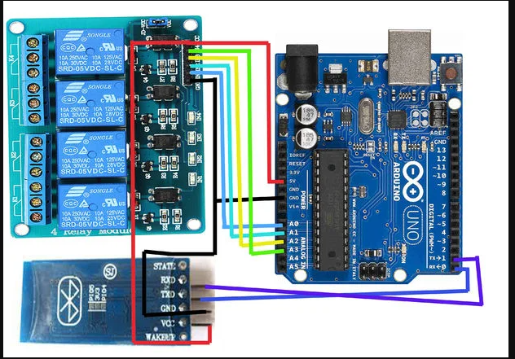

**BLOCK DIAGRAM:**



**FUNCTIONS OF BLOCK DIAGRAM:**

**ARDUINO UNO:** The device has multiple input and output pins for controlling multiple unit and sensors, also for receiving input for multiple sensors and different input devices.

**BLUETOOTH MODULE HC-05:** The Bluetooth can receive input signal from any a device which have Bluetooth compatibility such as smartphone.

**BLUETOOTH VOICE CONTROL FOR ARDUINO:**

This app uses voice recognition in android mobiles to pass voice commands to central control. It pairs with Bluetooth modules and sends the voice commands in the form of a string.

**4-CHANNEL RELAY MODULE:** It is basically an electromagnetic switch which can be turn on and off by an applying the voltage across its contacts. It Woks simply by providing small electrical power in form of electrical signal.

**COMPONENTS USED:**

* Arduino UNO
* Bluetooth Module HC-05
* 4-Channel Relay module (Relay Board)
* Power supply
* Connecting wires
* Bread board
* LED
* Buzzer

**HARDWARE DETAILS:**

**Arduino UNO:**

It is a hardware which have a programmable IC Atmega328P and programmed by using computer software Arduino IDE. The device has multiple input and output pins for controlling multiple unit and sensors, also for receiving input for multiple sensors and different input devices. The Arduino board exposes most of the microcontroller's I/O pins for use by other circuits. The current Uno provide 14 digital I/O pins, six of which can produce pulse-width modulated signals, and six analog inputs, which can also be used as six digital I/O pins. These pins are on the top of the board, via female 0.1-inch (2.54 mm) headers. Several plug-in application shields are also commercially available.

**Bluetooth Module HC-05:**

For this wireless home automation, we will use Bluetooth module HC-05. HC-05 is an easy-to-use Bluetooth SPP module (Serial Port Protocol) for wireless connection setup. In the Bluetooth HC-05 module, there are pins for VCC (5V), GND, TX, and RX. RX and TX pins of the module will be connected with the UART pins of Arduino UNO. Arduino Uno has a single UART interface found on pin 0 (RX0) and pin 1 (TX0). The HC-05 is an easy to connect and easy to used Bluetooth module, which is designed for wireless serial connection. The Bluetooth module can be used as master or slave configuration, making it best solution for wireless connection or communication. This module is version 2.0 Bluetooth communication technology which is great for transferring and receiving data in fast rate.

**4-CHANNEL RELAY MODULE:**

The mechanical relay has capability for acting as switch for turning on and off electrical loads. They Woks simply by providing small electrical power in form of electrical signal. This allows high power loads controlled by using small amount of power. A relay can be used to control high voltage electronic devices such as motors as well as low voltage electronic devices such as a light bulb or a fan. The mechanical relay uses electromechanical coil to open and close the circuit. When small number of current passes through coil it excites the coil and generates magnetic field and either pull the bar or release the bar which is used for opening and closing the circuit, here opening and closing means restricts flow of current.

**WORKING PRINCIPLE:**

In this project, a simple Voice Activated Home Automation system is designed. Voice commands are used to control different appliances.

After making the necessary connections, we have to switch on the power supply to the circuit. Now, we need to pair the Phone’s Bluetooth to the HC – 05 Bluetooth Module. Before that, we have to install the App mentioned above in the phone. The home screen of the app looks something like this.

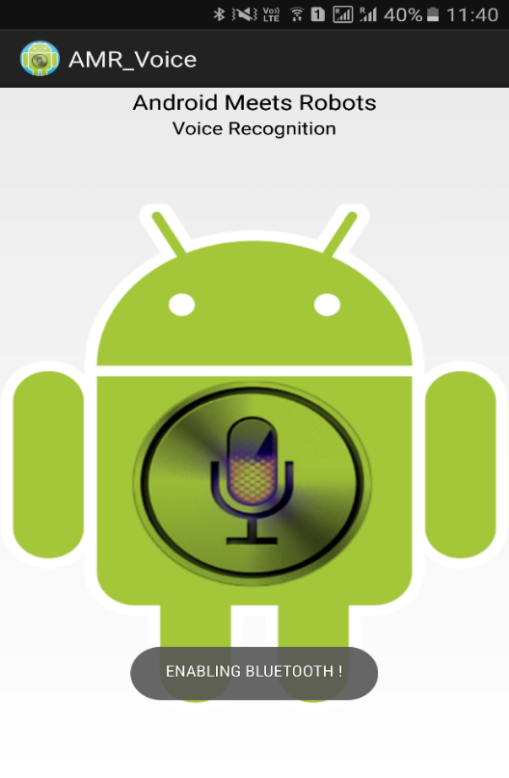

Next step is to connect the phone with the Bluetooth module. For this, choose the option “Connect Robot” and select the appropriate Bluetooth Device. If the devices aren’t paired earlier, we need to pair them now using the Pin of the Hc

05 Bluetooth Module.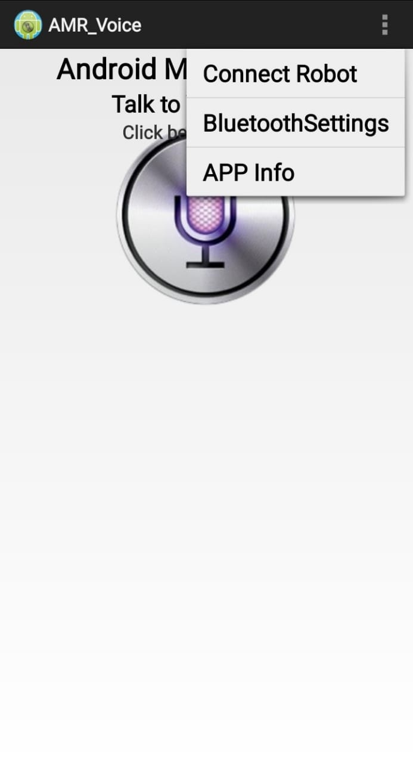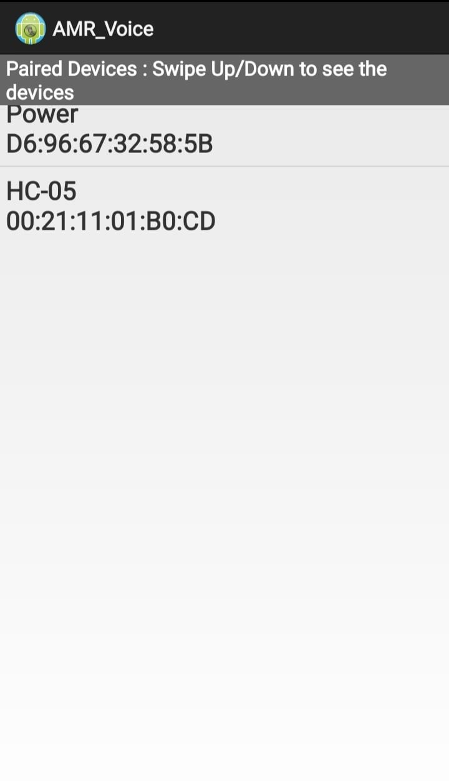

After successful connection, the devices are ready to transmit data. For that, press the press microphone icon on the app and start giving voice commands.

For example, if we press the microphone icon and say “turn on light”, the app will recognize the command and the transfers it to the Bluetooth Module. Also, the command gets displayed on the screen for our reference. 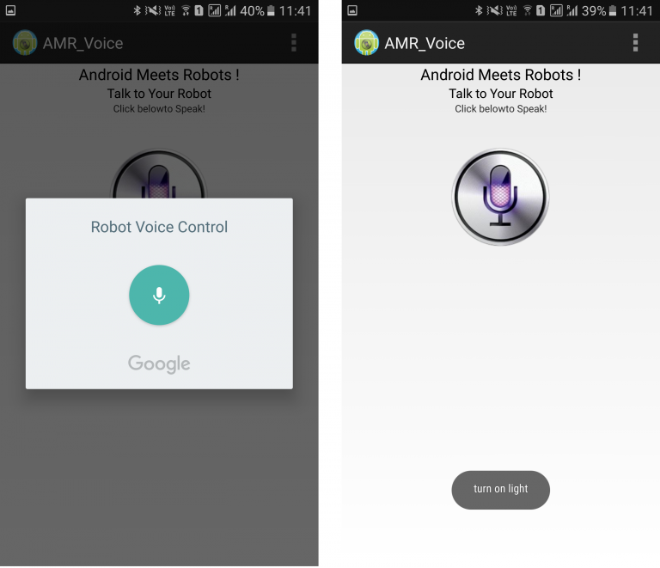

We have used the following commands: “turn on light”, “turn off light”, “turn on LED”, “turn off LED”, “turn on buzzer”, “turn off buzzer”, “turn on fan”, “turn off fan.

**APPLICATIONS:**

* It helps is to control a number of appliances through a common network easily by simple voice commands.
* You can manage all your devices from one place.
* This system will prove to be highly useful for people with are old or disabled.
* With voice-activated home automation system, you can make your space more energy efficient and can improve your home management.

**CONCLUSION:**

The project is designed by keeping in mind needs of all consumers for performing operation of turning on and off electrical appliance by using user interface device by giving voice commands wirelessly. The Bluetooth module can be removed and instead of Bluetooth module high range communication device can be implemented in system for better and reliable use of system.

**PHOTOS OF THE PROJECT:**

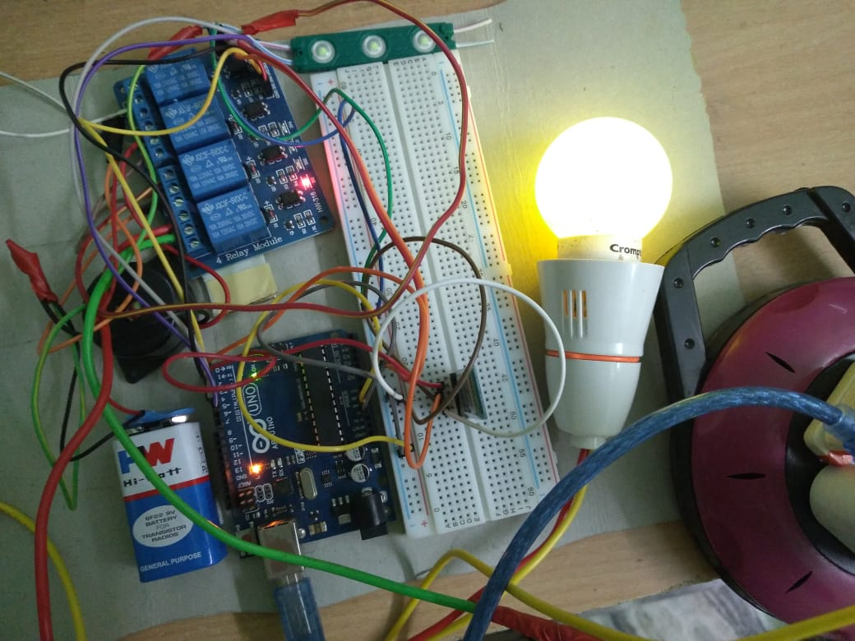

**REFERENCES:**

1. <https://www.electronicslovers.com/2018/06/voice-activated-home-automation-by-using-arduino-iot-smart-home.html>
2. <https://www.electronicshub.org/voice-activated-home-automation/>
3. <https://www.instructables.com/Voice-Control-Home-Automation/>
4. <https://www.electroduino.com/voice-controlled-home-automation-using-arduino-and-hc-05-bluetooth-module/>
5. <https://microcontrollerslab.com/voice-controlled-home-automation/>